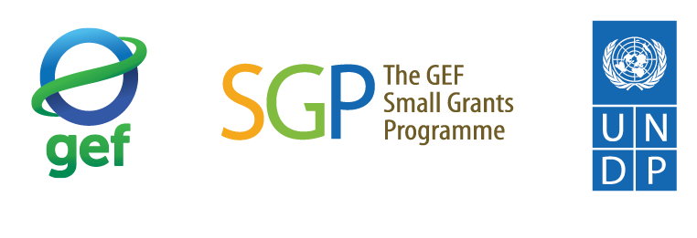

全球社区保护地支持计划第2阶段
THE PHASE 2 OF THE GLOBAL SUPPORT INITIATIVE TO TERRITORIES AND AREAS CONSERVED BY INDIGENOUS PEOPLES AND LOCAL COMMUNITIES
项目建议书
PROJECT PROPOSAL TEMPLATE

第一部分 项目概况 PART 1: PROJECT COVER PAGE

- 主要信息 GENERAL INFORMATION
国家/地区
Country
项目编号  Project No. | 本项仅由SGP官员填写。  For SGP Official Use as relevant. Do not write anything here
项目名称
Project Title:
提交日期
Submission date

- 民间机构/社区机构申请者 CIVIL SOCIETY/COMMUNITY BASED ORGANIZATION – APPLICANT
机构名称
Name of organization
成立日期
Year established
地址
Physical & Mailing Address
电话
Telephone
电子信箱
Email
负责人（姓名及职务）
Principal Officer (name and position)
联系人（姓名及职务）
Project contacts (names and positions)

- 项目点 PROJECT LOCATION
陆地景观/海洋景观/社区保护地名称
Landscapes/Seascape/ICCAs (name)
省（自治区）/区（县）/村
State/District and Town/Village
坐标（经度/纬度）
Coordinates (latitude/longitude)

- 项目类别（如有需要，请咨询国家协调员/国家指导委员会）
GEF SMALL GRANTS PROGRAMME CLASSIFICATION (please consult NC/NSC as needed)
每个项目需从以下表格中选定一个重点SGP战略举措和一个重点关注领域。项目可能还会有次要的战略举措和关注领域，这些内容应在项目合理性论证和实施方法中予以注明。申请者应根据项目的主次重点领域选择合适的指标（请参考附件 1）。
Each project will select one primary SGP Strategic Initiative and one primary Focal Area as indicated in the tables below. Projects may have secondary Strategic Initiative and Focal Areas which should be noted in the project justification and approach. Appropriate indicators should be selected in line with the primary and secondary focal areas of the project (refer to the annex 1 below)
重点战略举措（请在以下类别勾选一个）  Primary Strategic Initiative  (choose one primary Initiative) |  |  | 重点关注领域（请在以下类别勾选一个）  Primary Focal Area  (choose one primary focal area)
 | 社区保护的受威胁的生态系统和物种  Community-based conservation of threatened ecosystems and species |  |  | 生物多样性  Biodiversity
 | 可持续农业、渔业以及粮食安全  Sustainable agriculture and fisheries, and food security |  |  | 减缓气候变化  Climate Change Mitigation
 | 低碳能源可及性的协同效益  Low-carbon energy access co-benefits |  |  | 土地退化/可持续的土地与森林管理  Land Degradation/Sustainable Land and Forest Management
 | 从当地到全球的化学品和垃圾管理联盟  Local to global coalitions for chemicals and waste management |  |  | 化学品和垃圾管理  Chemical and Waste Management
 | 促进可持续的城市解决方案  Catalyzing sustainable urban solutions |  |  | 国际水域  International Waters
 | 提升能力建设/网络建设  Enhancing capacity building / network construction |  |  | 能力建设  Capacity Building

- 项目时长 PROJECT DURATION
项目开始时间Proposed Start Date
项目持续时间（月）
Project duration (in months)

- 项目经费 PROJECT FINANCE
经费来源 Financial sources | 人民币 Local Currency | 美元 USD currency
从GEF SGP申请的经费
Total fund request from GEF SGP
配套资金（现金和非现金）
Total fund from cofinancing (cash and in-kind)
项目总经费 Total Project Cost

- 符合条件的申请机构 ORGANIZATION – ELIGIBILITY
请陈述申请机构在成功实施所申请项目领域的相关经验以及其具备的实施条件：
Please describe proposing organization’s experience and eligibility to successfully implement the proposed project:
- 机构类别 Type of organization
☐ 社区机构 Community-based organization (CBO)
☐ 社会组织 Civil society organization (CSO)
此外，根据实际情况选择以下一项或多项
In addition, choose one or more of the following as appropriate:
☐ 少数民族团体 Indigenous Peoples organization
☐ 妇女团体 Women’s group
☐ 青年团体 Youth Group
☐ 残障人士团体 Persons with Disabilities group

- 机构成立年限或项目管理经验（如有）：_______年
Length of existence and project management experience if any: _____ years

- 简要描述机构/团体的目的及核心的活动：如有，可包含机构的使命/愿景
Briefly describe purpose and core activities of the proposing organization/group: include a mission/vision statement as appropriate.

- 简要描述机构结构、治理架构和行政框架，包括员工人数、职责等。附上统一社会信用代码登记证书。若有最近的经过审计的财务报表，请一并提供。
Briefly describe organizational structure, governance and administrative framework, including staff numbers, roles, etc. Provide an indication of the legal status with any supporting registration/legal documentation as annex. If none, provide an elaboration of its nature of existence. Provide recent audited financial statement if any.

- 请描述与申请项目相关的过往经历，包括与全球环境问题相关的活动；或者具有专注于社区层面可持续发展的项目经验。
Describe previous experience relevant to the proposed project, including activities related to global environmental issues; or experience with projects that focus on sustainable development at community level.

- 请说明该机构先前参与GEF SGP的情况（例如：受资助方、合作伙伴等）。是/否：如果是，请描述其参与的性质，包括参与的具体项目以及所获得的资助情况。
Please indicate the organization’s prior engagement with GEF SGP (e.g. grantee, partner, etc). Yes/No: If yes, describe the nature of the involvement including involvement in specific projects and grants received.

------------

第二部分项目建议书 PART 2: PROJECT PROPOSAL

SECTION A: 项目框架 PROJECT FRAMEWORK

- 项目摘要 Project Summary
请用一段话简要概括项目，包括申请的理由和背景、项目目标及关键预期的成果，并包含项目地点和所涉及的社区。请按照项目实际涉及的地区对ICCA GSI第2阶段优先地理区域进行勾选。
Please provide a brief summary of the project in one paragraph, including rationale and context, project objective and key expected results, include the target site and community(ies) involved.

☐ 1）东亚-澳大利西亚候鸟栖息地
☐ 2）印缅生物多样性热点区
☐ 3）南方风水林

1）东亚-澳大利西亚候鸟栖息地
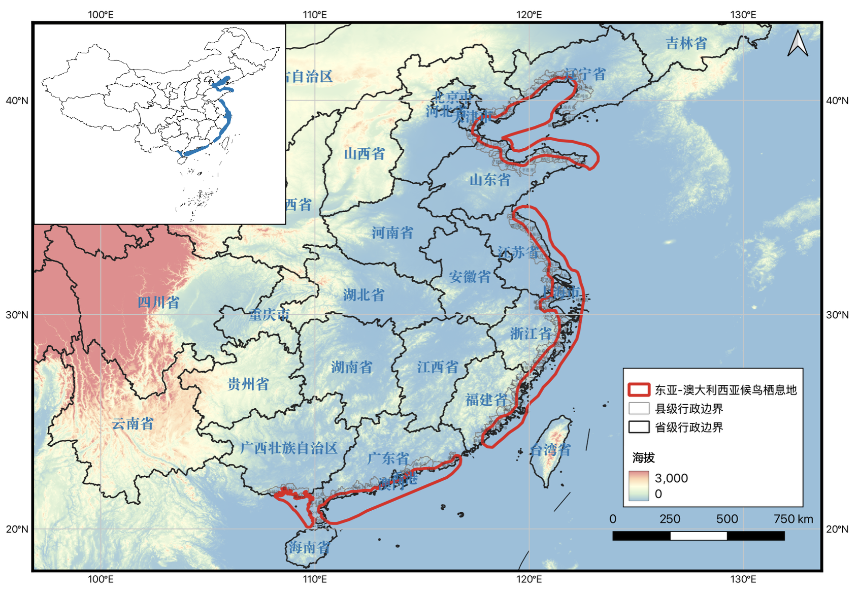
海域部分
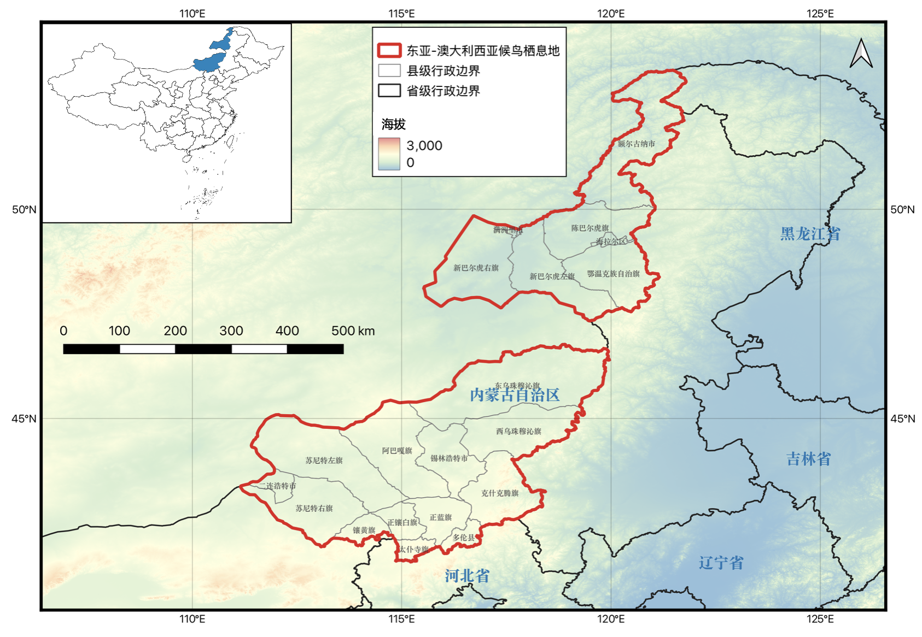
陆域部分
区域范围 | 包含NBSAP中的黄渤海区、东海及台湾海峡区、南海区的一部分（不包括离岸的岛屿和海域），以及锡林郭勒草原区和呼伦贝尔区。  具体包括我国从辽宁鸭绿江口到雷州半岛的沿海海岸带、岛屿及近海海域，以及内蒙古自治区中东部和东北部的候鸟栖息地。
区域坐标 | 海域部分：东经 108°07′～123°14′，北纬 20°03′～ 41°04′  陆域部分：东经 111°09′～121°48′，北纬 41°34′～ 53°17′
区域总公顷数 | 海域部分：31,290,100公顷  陆域部分：33,178,300公顷
陆域/海域类型 | 陆域与海域相结合：其中海域部分包括红树林、海草床、珊瑚礁、牡蛎礁、礁石海岸、潟湖、海岛、养殖塘、盐田、泥质滩涂、沙滩等；陆域部分包括温带草原、淡水湖泊和湿地。

2） 印缅生物多样性热点区
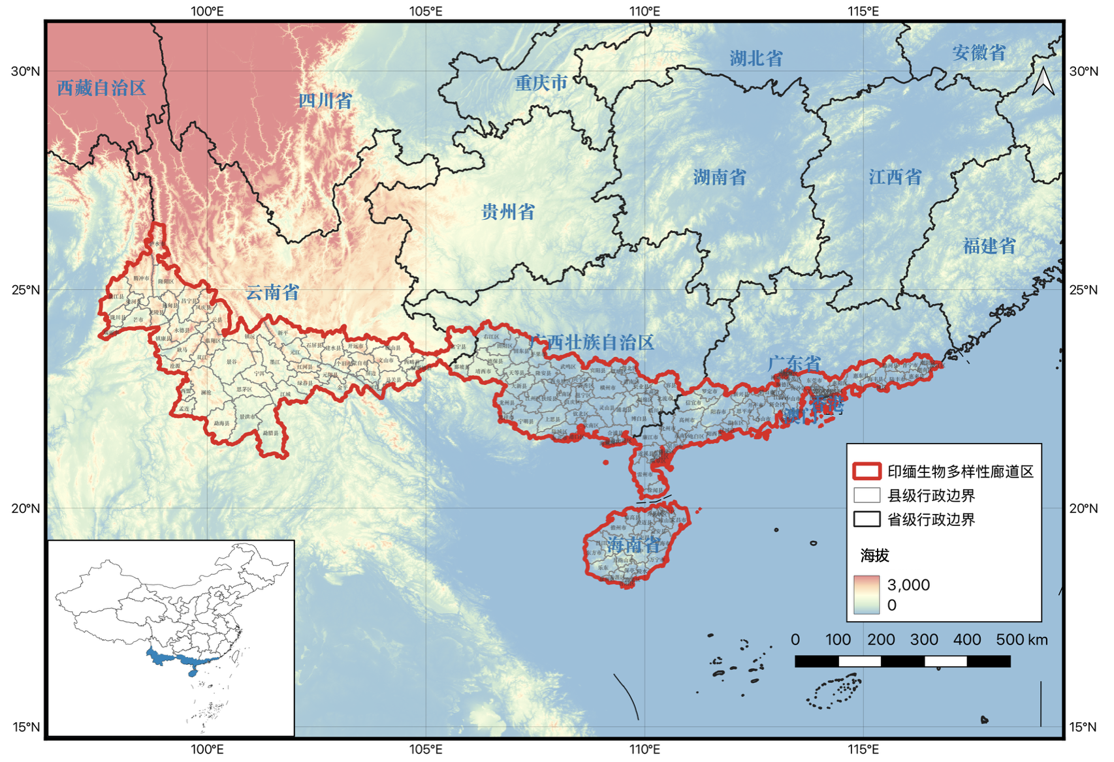
区域范围 | 包含CEPF印缅生物多样性热点地区的中国部分。具体包括云南省西部和南部、广西西南部和南部、广东南部和海南岛。该区域范围包含了NBSAP中的西双版纳、桂西南山地以及海南岛中南部生物多样性保护优先区域。
区域坐标 | 东经97°34′～116°49′，北纬18°08′～26°31′
区域总公顷数 | 38,614,500公顷
陆域/海域类型 | 陆域：山地；森林（热带季风雨林、热带雨林、亚热带常绿阔叶林、南亚热带季风常绿阔叶林等）。

3） 南方风水林
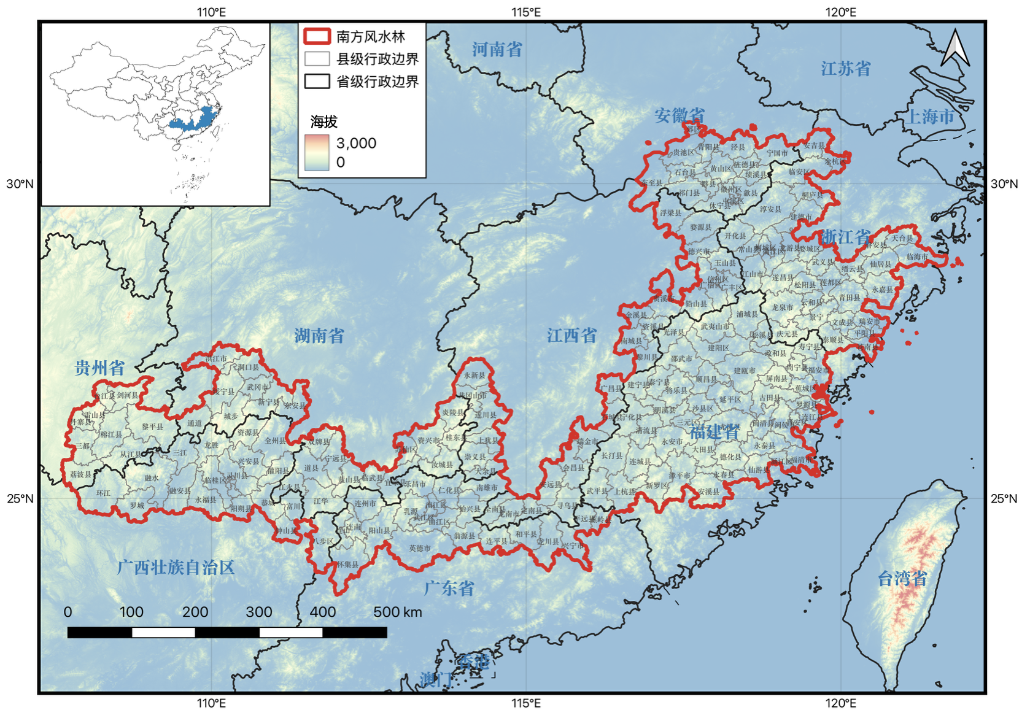
区域范围 | 包含NBSAP中的黄山-怀玉山、武夷山、南岭生物多样性保护优先区域。具体包括（1）浙江、安徽、江西三省交界的低山丘陵地区、（2）浙江、福建、江西三省交界的山地丘陵地带，以及（3）南岭山区（包括江西、湖南、广东、广西和贵州五省区的部分地区）。
区域坐标 | 东经101°38′～121°42′，北纬23°27′～31°00′
区域总公顷数 | 39,740,400公顷
陆域/海域类型 | 陆域：山地；丘陵；森林（亚热带常绿阔叶林）。

- 项目合理性论证与基线信息 Project Justification and Baseline
请描述以下内容 Please describe the following:
- 项目旨在解决的与全球环境和发展问题相关的挑战。
The challenges that the project intends to address in relation to global environmental and development issues.
- 项目如何关联并将如何贡献于ICCA-GSI的国家战略。
How the project relates and will be contributing to the ICCA-GSI Country Programme Strategy
- 项目与政府、GEF及其他出资方和私营部门支持的其他相关计划的关联性。
How the project relates to other relevant programmes supported by government, GEF and other donors, and the private sector.

- 项目目标、成果/产出和活动 Project Objectives, Results/Outputs, and Activities
请填写表1来描述项目框架和实施计划：
Please describe the project framework and implementation plan by completing the table 1 below:
- 首要目标：项目应当包括环境目标，以及相关的发展或生计目标。
Primary objective: Proposed project should include environmental objective, along with development/livelihood objective as relevant.
- 项目成果：请描述由于项目的实施，在项目结束时会发生什么可量化的变化（例如：建立了XX公顷的社区保护地；XX名社区成员获得培训并改进了垃圾管理）。
Project results: Please describe measurable changes which will have occurred by the end of the project as a result of the planned intervention (e.g. XX hectares of community management conservation area established. XX community members trained and improved on waste management).
- 项目产出和活动：请简要描述项目的预期成果和产出。请为每个产出概述几项活动。
Project Outputs and Activities: Please briefly describe what will be produced as project results and outputs. Please outline few activities for each output,
- 项目实施计划和时间框架：请概述活动的时间安排、所需报告、项目审查和监督。
Project Implementation Plan and Time Frame: Please include timing of the activities, required reports, project reviews and monitoring activities.

表1：项目框架和实施计划 Table 1: Project framework and Implementation Plan
项目目标  Project Objective: XXXX |  |  | 活动开展的时间（按月或季度）  Timing/Duration of Activity in Months (or Quarters)
项目框架  Project Framework | 负责方  Responsible  Party | 指标  （包括验证方法）  Indicator, including means of verification | 1 | 2 | 3 | 4 | 5 | 6 | 7 | 8 | 9 | 10 | 11 | 12
组成部分/产出1
Component/Output 1:
XXXXX

活动1.1
Activity 1.1: XXXXX

活动1.2
Activity 1.2: XXXXX

活动1.3
Activity 1.3: XXXXX

组成部分/产出2
Component 2/Output 2: XXXXXX

活动2.1
Activity 2.1: XXXXX

活动2.2
Activity 2.2: XXXXX

监督及评估
Monitoring and Evaluation
- 中期审查和报告
Mid-term review and reporting
- 最终审查和报告（包括ICCA-GSI项目管理工具和ICCA安全与韧性指数评估）
Final review and reporting including the ICCA-GSI Project Monitoring Tool and ICCA Security and Resilience Index assessment

社区和利益相关方参与的计划 Community and Stakeholder Participation Plan
请描述利益相关方和社区（包括相关的原住民）如何以及将在以下方面参与：i) 项目规划与设计；ii) 项目实施；iii) 项目监测与评估。请酌情附上相关文件（如利益相关方或社区会议纪要等）。

Please describe how the stakeholders and communities, including indigenous peoples where relevant, were and will be involved in: i) project planning and design: ii) project implementation and iii) project monitoring and evaluation. Please attach documentation as relevant.

包容性——妇女、原住民、青年和残障人士

Inclusion –Women, Indigenous Peoples, Youth, and Persons with Disabilities:

请描述项目如何考虑：

男性和女性的角色和需求（特别是关注女性的需求），

其他社会包容性群体（原住民、青年和残障人士）的需求，以及

这将如何在项目的预算和成果中体现，并如何给项目带来益处。

Please describe how the project takes into consideration:

The roles and needs of both men and women (with a special focus on the needs of women),

Other social inclusion groups (indigenous peoples, youths and persons with disabilities), and

How this would be reflected in the budget, results and benefits of the project.

影响——可持续性、推广和复制 Impact – Sustainability, Scale-up and Replication:
请描述项目影响在长期内的可持续性，包括环境和社会经济方面。概述在项目实施前、实施中及项目结束后所可能采取的步骤，以确保在项目结束后，项目的影响还能持续很多年（例如：谁来管理活动/成果的延续，如何进行融资等）。

Please describe the sustainability of the project impact in the longer term, both environmentally and socio-economically. Outline possible steps to be taken before, during, and at project completion to ensure that the project impact will continue for many years after the project ends (i.e. who will manage the continuation of the activities/outcome, how will it be financed, etc.).

创新 Innovation
请描述项目的创新方面。这可能包括新的思维方式、新的资源机构形式、新的社区内部连接方式、对已有产出/服务/交付流程的改进、原创的产品/服务/交付模式，以及如何推动当地行动和机构形成团体。

Please describe innovative aspects of the project. This may include new way of thinking, new form of organizing resources, new ways to connect within community, improvements of existing product/service/delivery process, original product/service/model of delivery, and fueling local action and organizing as groups.

知识管理 Knowledge Management
请描述如何计划获取、分享和传播通过项目实施所得到的知识、经验教训和最佳实践。请具体说明本项目将生成的知识产品。

Please describe the plan to capture, share and disseminate the knowledge, lessons learned, and good practices gained through the implementation of the project. Please specify the knowledge products to be generated by this project.

SECTION B: 项目风险、监督与评估 PROJECT RISKS, MONITORING & EVALUATION

- 项目风险Project Risks
请描述可能导致项目未能产生预期结果的主要的风险因素。这些因素应包括内部因素（例如所采用的技术未能按预期运作）和外部因素（例如政治和经济状况等）。同时，请写出应对潜在风险的缓解措施。
Please describe major risk factors that could result in the project not producing the expected results. These should include both internal factors (e.g. technology involved fails to work as projected) and external factors (e.g., political and economic situation, etc.). Please also propose risk mitigation measures to address the potential risks.

表2 风险因素与缓解措施 Table 2:Risks and Mitigation Measures

# | 内部及外部风险因素  Internal and External Risks | 可能的缓解措施  Possible mitigation measures
1
2
3

监督&评估计划及指标 Monitoring & Evaluation Plan and Indicators (please consult with the NC/NSC)
- 项目监督时间表 Project monitoring schedule
请明确年度、中期和终期监督的时间表，并将其纳入项目框架与实施计划（上列表1）中。
Please identify annual, mid-term, and final monitoring schedule and incorporate in the Project Framework and Implementation Plan (table 1 above).

项目指标 Project indicators
请填写附件2的ICCA-GSI指标——此为所有项目的必填项。
请根据ICCA-GSI项目的实际情况填写附件1的GEF SGP 第8执行阶段指标。

Please fill in Annex 2 for ICCA-GSI indicators- this is a requirement for all projects.

Please fill in Annex 1 for GEF SGP OP8 as relevant to the ICCA-GSI project

SECTION C: 项目预算 PROJECT BUDGET

如有问题，请咨询国家协调员/国家指导委员会 (Please seek support from NC/NSC as needed)

项目预算 Project Budget
请按以下支出类别提供预算明细，并说明资金在项目周期内的使用计划。同一个机构在同一个执行期内申请的金额不超过50,000美元，且SGP项目周期通常不超过2年。鼓励提供不低于SGP赠款数额的等额或更高金额的配套资金。

Please provide budget details following the expenditure categories below, and how the funds will be spent over the project period. GEF SGP grant requests should not exceed fifty thousand United States Dollars (US$50,000) per project and per Operational Phase. SGP projects generally should not exceed 2 years. Cofinancing of equal or more amount to the SGP grant amount is encouraged.

Table 3: 项目预算（以当地货币和/或美元计）Project Budget (in local and/or USD currency)
预算类别  Expenditure Category | 从SGP申请的资金（金额，及占总预算百分比）  SGP Grant (Amount and Percentage of the total budget) | 配套资金（来自社区与其他捐赠方等的现金与实物）Cofinance (both cash and in-kind from community, donor, etc.)
1 . 人力/劳力（请写清具体明细）
Personnel / Labor (please provide detailed breakdown)

2. 设备（请写清具体明细）
Equipment / Materials (please provide detailed breakdown)
3. 培训/讨论会/研讨会/差旅等（请写清具体明细）Training / Workshops/ Seminars / Travel (please provide detailed breakdown)
4. 分包合同（请写清具体明细）
Contracts (please provide detailed breakdown)
5. 监督，评估和知识管理（请写清具体明细） Monitoring, Evaluation and Knowledge management (please provide detailed breakdown)
项目合计成本
Total Project Cost

- Cofinancing 配套资金
请提供有关成本分摊贡献（现金和实物）的详细信息，并总结于下表4中。配套资金应直接与项目成果的实现相关，包括人力、材料、时间及其他可量化的资源。需注明贡献来源及性质（例如：青年机构提供人力、土地、现金等）。GEF SGP遵循相关合作伙伴共同分担项目目标活动成本的原则，因此项目申请机构需对项目的运营及计划成本作出一定贡献。
Please provide details on the cost-sharing contributions (cash and in-kind) and summarized in table 4 below. Cofinancing should be directly related to the achievement of the project results, such as labor, materials, time and other quantifiable resources that count towards. This should include sources and nature of the contribution (e.g. Youth Organization contributing labor, land, cash, etc.). The GEF SGP applies the principle of co- financing the target activities between the relevant partners in the project. It is therefore important that proposing organizations make some contribution towards the operational and programmatic costs of the project.

Table 4: Cofinancing 配套资金
资金来源  Sources of Contribution | 现金配套  Cash cofinance | 非现金配套In-kind Cofinance | 配套资金情况  （已确认/预计*）Cofinance is Committed or Projected* | 金额（人民币）Amount  (in local currency)
社区
Community
项目申请机构
Proposed organization
捐赠方（请具体说明）
Donor (please specify)
当地政府部门
Local government
其他（请具体说明）
Other (please specify)
合计
Total

ANNEX 1: INDICATORS 指标

GEF SGP 第8执行阶段的项目指标（详情请参阅监测与评估指南）

GEF SGP OP8 Project Indicators (please refer to M&E guidelines for details)
所有SGP项目都应符合以下至少一个或多个全球环境指标。SGP的重点领域与GEF-8规划指导文件及其成果保持一致，以实现GEF-8目标。为获取全球环境效益，GEF-8 SGP与11项GEF-8核心指标中的6项保持一致。
All SGP projects will align with at least one or more of the below global environmental indicators. The SGP priorities are aligned to that of the GEF-8 Programming Directions Paper and its outcomes to meet the GEF-8 targets. To capture global environmental benefits, GEF-8 SGP is aligned with 6 of the 11 GEF-8 core indicators.

SMALL GRANTS PROGRAMME INDICATORS FOR GEF-8

GEF-8小额赠款计划指标
PROJECT LEVEL INDICATORS项目层面指标
MANDATORY Global Environmental Indicators: at least one indicator and no more than three (aligned with GEF 8 Core Indicators)  强制性全球环境指标：至少选择一项指标，至多不超过三项（与GEF-8核心指标对应） |  | Type  指标类型
GEF CORE indicator 1  Terrestrial protected areas created or under improved management  GEF核心指标 1  新建立或管理得到改善的陆地保护区 | - Terrestrial protected areas newly created  新建立的陆地保护区  1.2 Terrestrial protected areas under improved management effectiveness管理有效性得到改善的陆地保护区 | Mandatory: A given project can be linked to at a minimum one core indicator; and at most three of these GEF-8 core and sub-indicators  强制性指标：一个特定项目至少需关联一项核心指标；最多可关联三项GEF-8核心及子指标
GEF CORE indicator 2  Marine protected areas created or under improved management (hectares)  GEF核心指标 2  新建立或管理得到改善的海洋保护区（公顷） | 2.1Marine Protected Areas Newly created (hectares)  新建立的海洋保护区（公顷）  2.2 Marine Protected Areas Under improved management effectiveness (hectares) 管理有效性得到改善的海洋保护区（公顷） | Mandatory: A given project can be linked to at a minimum one core indicator; and at most three of these GEF-8 core and sub-indicators  强制性指标：一个特定项目至少需关联一项核心指标；最多可关联三项GEF-8核心及子指标
GEF CORE Indicator 3. Area of land and ecosystems under restoration  GEF核心指标 3  得到恢复的土地和生态系统面积 | 3.1 Area of degraded agricultural lands (cropland, range land and pasture) under restoration (hectares)  得到恢复的退化农业用地（耕地、牧场）面积（公顷）  3.2 Area of forest and forest land under restoration (hectares)  得到恢复的森林和林业用地面积（公顷）  3.3 Area of natural grass and woodland under restoration (hectares)  得到恢复的天然草地和林地面积（公顷）  3.4 Area of wetlands (including estuaries, mangroves) under restoration (hectares)  得到恢复的湿地（包括河口、红树林）面积（公顷）
GFE CORE Indicator 4 Area of landscapes under improved practices (hectares; excluding protected areas)  GEF核心指标 4  采用改进实践管理的景观面积（公顷；不包括保护区） | 4.1 Area of landscapes under improved practices (excluding protected areas) (hectares)  采用改进实践管理的景观面积（不包括保护区）（公顷）  4.2 Area of landscapes under third-party certification incorporating biodiversity considerations (hectares)  采用纳入生物多样性考量的第三方认证的景观面积（公顷）  4.3 Area of landscapes under sustainable land management in production systems (hectares)  生产系统中采用可持续土地管理的景观面积（公顷）  4.4 Area of High Conservation Value or other forest loss avoided (hectares)  避免了损失的高保护价值区域或其他森林（公顷）  4.5 Terrestrial OECMs supported (hectares)  支持了的其他有效的区域保护措施的面积（公顷）
GEF CORE Indicator 5 Area of marine habitat under improved practices to benefit biodiversity (excluding protected areas)  GEF核心指标 5  采用改进实践以惠及生物多样性的海洋生境面积（不包括保护区） | 5.3 Marine OECMs supported (numbers)  获得支持的海洋类型其他有效的区域保护措施的数量
GEF CORE Indicator 6 Greenhouse Gas Emissions Mitigated (metric tons)  GEF核心指标 6  温室气体减排量（公吨） | 6.1 Carbon Sequestered or Emissions Avoided in the AFOLU (Agriculture, Forestry and Other Land Use) sector (metric tons)  农业、林业及其他土地利用（AFOLU）部门实现的固碳量或减排量（公吨）
6.2 Emissions Avoided Outside AFOLU (Agriculture, Forestry and Other Land Use) Sector (metric tons)
农业、林业和其他土地利用部门之外实现的减排量（公吨）

6.3 Energy Saved (Use this sub-indicator in addition to the sub-indicator 6.2 if applicable) (metric tons)
节约的能源（如有，此项指标应作为6.2的补充指标）（公吨）

6.4 Increase in Installed Renewable Energy Capacity per Technology (Use this sub-indicator in addition to the sub-indicator 6.2 if applicable) (capacity watt)
按技术分类新增可再生能源装机容量（如有，此项指标应作为6.2的补充指标）（容量：瓦）

11 | Number of direct beneficiaries disaggregated by gender as co-  benefit of GEF investment (this is also put below under mandatory socio-economic indicators)  作为GEF投资共同效益的直接受益者数量，按性别分列（此指标也列在下方的强制性社会经济指标中）
MANDATORY: Socio- Economic Benefit Indicators 强制性指标：社会经济收益指标 |  | Type 类别
1 | Number of direct beneficiaries with improved livelihoods and well-being  生计与福祉得到改善的直接受益人数 | Mandatory  强制性指标
2 | Number of direct beneficiaries benefitting from SGP intervention  从小额赠款计划干预措施中受益的直接受益人数 | Mandatory  强制性指标
3 | Breakdown number of beneficiaries reached by social inclusion groups (using 0 in case a category not applicable):  按社会包容性群体划分的受益人数（如没有其中某类，请填写0）
 | - Number of Women 女性人数; | Mandatory  强制性指标
 | - Number of Indigenous Peoples 原住民人数; | As relevant  视相关性而定
 | - Number of Youth 青年人数; | As relevant  视相关性而定
 | - Number of Persons with Disability 残障人士人数 | As relevant  视相关性而定
4 | Is the project tagged (for expected contribution at project commitment stage/ report on results in final report) to closing gender gaps in one or more of the following categories (check all applicable)?  本项目是否（在项目承诺阶段或最终报告的结果报告中）被标记为预期在以下一个或多个类别中缩小性别差距（请勾选所有适用的类别）？ | As relevant  视相关性而定
- contributing to equal access to and control of natural resources of women and men
促进男女平等获取和控制自然资源
- improving the participation and decision-making of women in natural resource governance
提高妇女在自然资源治理中的参与度和决策权
- targeting socio-economic benefits and services for women
为妇女提供社会经济收益和服务

5 | Does the project include sex-disaggregated and gender sensitive indicators (at commitment stage)  在承诺阶段，项目是否包括了分性别统计和具有性别敏感度的指标？ | As relevant  视相关性而定
6 | Does the project support legal identity and legal empowerment issues?  项目是否支持弱势群体法律身份和法律赋权相关议题？ | As relevant  视相关性而定

PROJECT LEVEL INDICATORS 项目层面指标
AS RELEVANT/OPTIONAL: Additional Indicators  视项目相关性而定/非强制性：附加指标  (These include both Global Environmental Benefit and Socio- Economic Benefit indicators  包括全球环境效益和社会经济效益指标) |  |  | Type  类别
SGP projects are multi- focal. Checkmark focal area strategy used (biodiversity, climate change mitigation/ adaptation, land degradation, sustainable forest management, international waters, chemicals and waste)  SGP 项目具有多重点领域特性。请勾选所采用的重点领域策略（生物多样性、气候变化减缓/适应、土地退化、可持续森林管理、国际水域、化学品与废物） |  |  | Due to multi-focal nature of SGP interventions, projects can select from all indicators across all focal areas while highlighting the focal area that will be their primary strategy.  由于SGP干预措施的多重点领域性质，项目可以从所有重点领域的指标中进行选择，同时突出其作为主要策略的重点领域。
1 | Names and Number of target landscapes/seascapes under improved community conservation and sustainable use  得到改善的社区保护地与可持续利用的目标陆地景观/海洋景观的名称及数量 | BD  生物多样性 | While primary focal areas for each indicator area listed, please note irrespective of focal area selected, a project can choose from any of these indicators to be linked to in case of multifocal and integrated results. Please note these are optional are optional in nature.  请注意：虽然列出了每个指标的主要重点领域，但无论选择哪个重点领域，在多重点领域和综合成果的情况下，项目都可以选择与任何这些指标建立关联。这些指标本质上都是可选的。
2a | Number of terrestrial Protected Areas (PAs) influenced  受影响的陆地保护区数量 | BD  生物多样性
2b | Number of marine Protected Areas (PAs) influenced  受影响的海洋保护区数量 | BD  生物多样性
3 | Number of ICCAs identified, supported and strengthened; Hectares of ICCAs  被识别、支持和加强的原住民和社区保护地数量；原住民和社区保护地面积（公顷） | BD  生物多样性
4 | Number of sustainably produced biodiversity and agrobiodiversity products  可持续生产的生物多样性产品和农业生物多样性产品数量 | BD  生物多样性
5 | Number of globally significant species with maintained or improved conservation status  保护状况得到维持或改善的全球重要物种数量 | BD  生物多样性
6 | Number of community members with improved actions and practices on agriculture, land and water management  在农业、土地和水资源管理方面采取改善行动和实践的社区成员数量 | LD  土地退化
7 | Number of new or sustained farmer leaders adopting and demonstrating improved agriculture and agroecological practices.  采用并示范改进的农业和生态农业实践的新增或已有的务农带头人数量 | LD  土地退化
8 | Number of new or sustained farmer groups or networks, advocating and disseminating improved agriculture approaches and practices.  倡导和传播改进的农业方法与实践的新增或已有的农民团体或网络数量 | LD  土地退化
9 | Number of partnerships to advance sustainable agriculture and fisheries and/or food security (such as diversification, sustainable intensification, sustainable fisheries management, agroecological farming practices, climate-smart agriculture, certification programmes, local sourcing initiatives, waste reduction and circular economy, etc.)  为推进可持续农业和渔业及/或粮食安全建立的伙伴关系数量（例如多样化、可持续集约化、可持续渔业管理、生态农业实践、气候智能型农业、认证计划、本地采购倡议、废物减量与循环经济等） | LD, BD  土地退化  生物多样性
10 | Number of projects working on: renewable energy (biomass, hydro, solar photovoltaic, solar thermal, other); energy efficiency, sustainable transport; and conservation/ enhancement of carbon stocks.  致力于以下领域的项目数量：可再生能源（生物质能、水能、太阳能光伏、太阳能热利用、其他）；能源效率；可持续交通；碳储量的保护/增强 | CC  气候变化
11 | Increase in installed renewable energy capacity from community-scale systems (e.g., biomass, micro-hydro, solar, etc.)  社区规模系统（例如，生物质能、微水电、太阳能等）新增可再生能源装机容量 | CC  气候变化
12 | Number of locally adapted solutions promoting low-carbon technologies (such as new/modified biogas technology, locally developed energy-efficient stoves, innovative uses of solar/wind energy, etc.)  促进低碳技术的本地适应解决方案数量（例如，新的/改良的沼气技术、本地开发的节能炉灶、太阳能/风能创新利用等） | CC  气候变化
13 | Number of households achieving energy access and co-benefits (such as, ecosystem effects, income, health and others)  实现能源可及性和协同效益的家庭数量（例如，生态系统效应、收入、健康等） | CC  气候变化
14 | Area of Forests and non-forest lands with restoration and enhancement of carbon stocks initiated through completed projects (hectares)  通过已完成项目启动的、恢复和增强碳汇的森林及非林地面积（公顷） | CC  气候变化
15 | Number of projects working on (check mark categories applicable): awareness and outreach solid waste management (reduce, reuse, recycle); sustainable pesticide management; organic farming; development of alternatives to chemicals  致力于以下领域的项目数量（勾选适用类别）：意识与宣传；固体废物管理（减量、再利用、回收）；可持续农药管理；有机农业；开发化学品替代品 | C&W  化学品与废弃物管理
16 | Checkmark and report all that apply: Kg of pesticides avoided, reduced or prevented; Kg of solid waste prevented or reduced (such as plastics, domestic waste, agricultural waste etc); Kg of harmful chemicals avoided from utilization or release; Kg of e-waste collected or recycled; Kg of mercury avoided, reduced or sustainably managed  请勾选并报告所有适用指标：避免、减少或防止使用的农药公斤数；防止或减少的固体废物公斤数（如塑料、生活垃圾、农业废弃物等）；避免使用或释放的有害化学物质公斤数；收集或回收的电子废物公斤数；避免、减少或可持续管理的汞公斤数 | C&W  化学品与废弃物管理
17 | Number of new or sustained local to global coalitions and networks on chemicals and waste management established or strengthened  在化学品与废物管理方面新建立或已有的，从地方到全球的联盟和网络数量 | C&W  化学品与废弃物管理
18 | Number of local policies and regulations developed to protect river-basin and marine ecosystems  为保护流域和海洋生态系统制定的地方政策法规数量 | IW  国际水域
19 | Tons of land-based pollution (such as solid waste, sewage, wastewater, and agricultural waste etc.) avoided, reduced or prevented from entering the waterbodies  避免、减少或防止进入水体的陆源污染吨数（如固体废物、污水、废水、农业废弃物等） | IW  国际水域
20 | Number of policy recommendations or advocacy initiatives related to land-based pollution as a result of SGP project  由SGP项目产生的、与陆源污染相关的政策建议或倡导倡议数量 | IW  国际水域
21 | Hectares of river/lake basins applying sustainable management practices through projects’ intervention  通过项目干预应用可持续管理实践的河流/湖泊流域面积（公顷） | IW  国际水域
22 | Number of people mobilized to support marine/river conservation  被动员支持海洋/河流保护的人数 | IW  国际水域
23 | Names of regional transboundary waterbodies/ Strategic Action Plans (SAPs) if applicable  区域跨界水域名称/战略行动计划（如有） | IW  国际水域
24 | Number of community-based sustainable solutions in urban landscapes (e.g., transport, biodiversity conservation, chemical and waste management, energy efficiency, watershed protection, etc.)  城市景观中基于社区的可持续解决方案数量（例如，交通、生物多样性保护、化学品与废物管理、能源效率、流域保护等） | All focal areas  所有重点领域
25 | Number of organizations with capacities built or developed (record for both): number of civil society organizations (CSOs), number of community-based organizations (CBOs)  能力得到建设或发展的机构数量（分别记录这两项）：社会组织数量；社区机构数量 | All focal areas  所有重点领域
26 | Number of beneficiaries with improved capacity  能力得到提高的受益者数量 | All focal areas  所有重点领域
Cross-cutting social inclusion project level indicators 跨领域社会包容性的项目层面指标
27 | Project led by women and/or institutes mechanisms for increased participation of women in decision-making? (Yes/ No)  项目是否由女性领导和/或建立了提升妇女参与决策的机制？（是/否） | GENDER  性别
28 | Number of indigenous leaders with higher capacities (to deliver local solutions and have strong policy advocacy representation)  能力得到提升的原住民领导者数量（这些人能够提供本地解决方案并具有强有力的政策倡导代表性） | IP  原住民
29 | Number of youth organizations engaged with as part of SGP intervention  SGP干预过程中参与合作的青年机构数量 | YOUTH  青年
30 | Number of PWD (persons with disabilities) organizations engaged as part of SGP intervention  SGP干预过程中所接触的残障人士机构数量 | PWD  残障人士
31 | Amount of grant funding of total grant portfolio accessed by: (a) women and/or women’s groups; (b) youth and/or youth-led groups; (c) Indigenous peoples’ groups.  获得赠款资金总额的金额：（a）妇女和/或妇女团体；（b）青年和/或青年主导的团体；（c）少数民族团体 | Inclusiveness  包容性
32 | Number of grantees received supporting legal identity and legal empowerment issues including the participation of Indigenous peoples and other remote/marginalized groups  在法律身份和法律赋权问题上获得支持的受赠方数量，包括对原住民及其他偏远/边缘群体参与的支持 | Inclusiveness  包容性
33 | Number of high-level policy changes associated with increased community participation in multi-stakeholder dialogue platforms  与多利益相关方对话平台中社区参与度提升相关的高级别政策变更数量 | Inclusiveness  包容性
34 | Number of representatives from social inclusion group (indigenous people, women, youth, persons with disability, farmers, other marginalized groups) meaningfully engaged in multi-stakeholder dialogue platforms  来自社会包容群体（原住民、妇女、青年、残障人士、农民、其他边缘化群体）的代表在多利益相关方对话平台中积极参与的人员数量 | Inclusiveness  包容性
35 | Number of CSO-government-private sector dialogues formed or strengthened.  建立或加强的社会组织-政府-私营部门对话机制的数量 | Inclusiveness  包容性

ANNEX 2: ICCA-GSI 第二阶段项目指标 ICCA-GSI Phase 2 Project Indicators
所有ICCA GSI 第2阶段的项目都将至少对接全球生物多样性框架（GBF）中的一个或多个目标，并符合德国联邦环境自然保护与核安全部（BMUV）国际气候倡议（IKI）所要求的标准指标。ICCA GSI第二阶段的优先事项与BMUV的法律协议及其成果保持一致，以实现IKI BMUV目标。为获取全球环境效益，ICCA-GSI第二阶段与23项全球生物多样性框架（GBF）目标中的4项保持一致。
All ICCA-GSI projects will align with at least one or more of the below Global Biodiversity Framework (GBF) targets and all mandatory indicators from the International Climate initiative (IKI) of the German Federal Ministry for the Environment, Nature Conservation, Nuclear Safety and Consumer Protection (BMUV). The ICCA-GSI Phase 2 priorities are aligned to legal agreements with the BMUV and its outcomes to meet the IKI BMUV targets. To capture global environmental benefits, Phase 2 of the ICCA-GSI is aligned to 4 of the 23 GBF targets.

关于GEF SGP 第8执行阶段的项目指标，请根据其与ICCA-GSI第2阶段项目的相关性，纳入上文表格中。
For the GEF SGP OP8 Project Indicators, please include in the tables above as relevant to ICCA-GSI Phase 2 projects.

PROJECT LEVEL INDICATORS项目层面指标
MANDATORY Global Biodiversity Framework Targets and Indicators  强制性指标：《全球生物多样性框架》目标与指标 |  | Type  类别
GBF Target  GBF 目标 | Indicator  指标
GBF Target 3  Conservation and protection of ecosystems and ensure that 30 percent of global land and sea areas are conserved/maintained by 2030  GBF 行动目标 3  到 2030 年，确保和促使至少 30%的陆地和内陆水域、海洋和沿海区域，特别是对生物多样性和生态系统功能和服务特别重要的区域处于具有生态代表性、连通性良好、公平治理的保护区系统和其他有效区域保护措施的有效保护和管理之下，酌情承认土著和传统领  地，使其融入更广泛的陆地景观和海洋景观，同时酌情确保这些区域的可持续利用活动完全符合保护成果，承认和尊重原住民和地方社区的权利，包括对其传统领地的权利。 | - Hectares positively influenced by ecosystem type (number)  按生态系统类型区分受到正面影响的面积（公顷数） | Mandatory: A given project can be linked to, at a minimum, one GBF Target.  Mandatory for Target 3: all indicators listed  强制性指标：一个特定项目至少需关联一项GBF目标。  针对GBF行动目标3，需要满足所有的指标。
GBF Target 21: Guide biodiversity action through knowledge-sharing of biodiversity information including the traditional knowledge, innovations, practices of IPs and LCs based on their free, prior and informed consent.  GBF 行动目标 21  确保决策者、从业人员和公众能够获取最佳现有数据、信息和知识，以便指导实现生物多样性的有效公平治理和综合、参与式管理，加强传播、提高认识、教育、监测、研究和知识管理，以及在这种情况下，应遵循国家法律，仅在得到其自由、事先和知情同意的情况下获取原住民和地方社区的传统知识、创新、做法和技术。  、 | - Projects supporting the protection/enhancement/promotion of Indigenous Peoples’ customary sustainable use practices of biodiversity (number)  支持保护/改善/推广社区传统可持续利用生物多样性实践的项目数量  - Projects supporting linguistic diversity of Indigenous Peoples and local communities (number)  支持社区语言多样性的项目数量  - Number of projects supporting traditional occupations of Indigenous Peoples and local communities (number)  支持社区传统职业的项目数量  - Knowledge-sharing workshops (number)  知识共享工作坊的数量  - Projects supporting the strengthening of inter-generational transfer(number) 支持加强代际知识传承的项目数量  - Legal and recognition agreements to ensure conservation and sustainable use of ICCAs (number)  确保社区保护地保护与可持续利用的法律和认可协议数量 | Mandatory: A given project can be linked to, at a minimum, one GBF Target.  强制性指标：一个特定项目至少需关联一项GBF目标。  Mandatory for Target 21: at least three of these GBF indicators  强制性指标：  针对GBF行动目标21，至少选择其中的3个指标。
GBF Target 22: Ensure Participation in Decision-Making and Access to Justice and Information Related to Biodiversity for all. Ensure participation of IPs and LCs in decision-making related to biodiversity.  GBF 行动目标 22  确保原住民和地方社区以及妇女和女童、儿童和青年、残疾人在决策中有充分、公平、包容、有效和促进性别平等的代表权和参与权，有机会诉诸司法和获得生物多样性相关信  息，尊重他们的文化及其对土地、领地、资源和传统知识的权利，确保充分保护环境人权维护者。 | - Indigenous Peoples and Local Communities are included in decision-making related to biodiversity conservation at project, local, national, regional and/or global levels. (number)  社区在项目、地方、国家、区域和/或全球层面参与与生物多样性保护相关的决策的数量  - National strategic documents incorporating ICCAs and related ecosystems as priorities for biodiversity conservation and adaptation to climate change (number)  将社区保护地及相关生态系统作为优先事项纳入生物多样性保护和气候变化适应国家战略文件的数量  - Territorial planning units that adopt ICCA recognition and governance assessments (number)  采纳社区保护地认可与治理评估的区域规划单元的数量  - Management plans and governance assessments updated to include ICCA legal, and others forms of recognition (number)  更新的管理计划和治理评估中纳入社区保护地的法律及其他认可形式的数量 | Mandatory: A given project can be linked to, at a minimum, one GBF Target.  强制性指标：一个特定项目至少需关联一项GBF目标。  Mandatory for Target 22: at least three of these GBF indicators.  强制性指标：针对GBF行动目标22，至少选择其中的3个指标
GBF Target 23: Ensure Gender Equality and a Gender-Responsive Approach for Biodiversity Action  GBF 行动目标 23  在《框架》执行过程中采用促进性别平等的方法确保性别平等，确保妇女和女童有平等的机会和能力为《公约》的三项目标作贡献，包括承认妇女和女童应有平等的权利和机会获得土地和自然资源，以及在与生物多样性有关的行动、接触、政策和决策的所有层面充分、公平、有意义和知情地参与和发挥领导作用。 | - Number of women-led projects (number)  女性主导的项目的数量  - Women representatives receiving support/capacity strengthening (number)  获得支持或能力建设的女性代表人数 | Mandatory: A given project can be linked to, at a minimum, one GBF Target.  强制性指标：一个特定项目至少需关联一项GBF目标。  Mandatory for Target 23: all indicators listed  强制性指标：  针对GBF行动目标23，需要满足所有的指标。
GBF Targets 3, 21, 22, 23  GBF目标3、21、22、23 | ICCA Security and Resilience Index assessment score carried out in line with ICCA self-strengthening methodology (number)  根据“社区保护地安全性及韧性评估工具”开展的社区保护地安全性与韧性指数评估得分 | Mandatory  强制性指标
Socio- Economic Benefit Indicators 社会经济效益指标
1 | Number of direct beneficiaries disaggregated by gender  分性别统计的直接受益人人数 | Mandatory  强制性指标
2 | Number of Youth as direct beneficiaries of the project, disaggregated by gender  分性别统计的项目直接受益青年人数 | Mandatory; very important for projects with inter-generational transfer outputs  强制性指标；对于包含跨代传承成果的项目尤为重要
3 | Number of indirect beneficiaries disaggregated by gender  分性别统计的间接受益人人数 | Mandatory  强制性指标
4 | Number of Youth as indirect beneficiaries of the project, disaggregated by gender  分性别统计的项目间接受益青年人数 | Mandatory; very important for projects with inter-generational transfer outputs  强制性指标；对于包含跨代传承成果的项目尤为重要
5 | Number of direct beneficiaries with improved livelihoods and well-being  改善生计和福祉的直接受益人人数 | Mandatory  强制性指标
6 | Number of Increase in livelihoods:  a. Amount of increase in incomes (number)  b. Amount of increase in food production (food security for subsistence communities) (number)  生计提升数量：  a.收入增加额  b. 食物产量增加额（保障自给社区的粮食安全） | Mandatory for at least 1 component of increase in livelihoods as relevant to the project  强制性指标，至少针对项目中相关的生计提升的一个组成部分
7 | Number of sustainably produced biodiversity and agrobiodiversity products  可持续生产的生物多样性及农业生物多样性产品数量 | As relevant  视项目相关性而定

Annex 3: INITIAL QUESTIONNAIRE BY APPLICANT GRANTEE

附件3：申请机构调查问卷

Grantee’s Information 申请机构信息

Project Title

项目名称

Name of applicant grantee

申请机构名称

Date 日期

Initial screening 初步筛选

Exempted Activities 豁免活动
Does the project fall exclusively into the following categories?  Projects that are comprised entirely of one or more of the following may be exempt from full screening. Projects are not required to fall into one or more of these categories for consideration.  项目是否完全属于以下类别？  完全由以下一项或多项组成的项目可免于全面筛查。项目无需为获得考量而必须属于以下一个或多个类别。 | Yes  是 | No  否
- Preparation and dissemination of reports, documents and communication materials

撰写报告、文件和宣传材料的编写与分发
- Organization of an event, workshop, training

机构活动、研讨会、培训会
- Strengthening capacities of partners to participate in international negotiations and conferences 加强合作伙伴参与国际谈判和会议的能力
- Partnership coordination (including UN coordination) and management of networks

伙伴关系协调（包括联合国协调）及网络管理
- Global/regional projects with no country-level activities (e.g. activities such as knowledge management, inter-governmental processes)

非国家级活动的全球/区域项目（例如知识管理、政府间进程等活动）

Conclusion of NC 国家协调员的结论
Exempted 豁免项目 | Yes是 | No  否

Annex 4: SUMMARY INFORMATION ON SOCIAL AND ENVIRONEMNTAL RISKS
附件 4：社会与环境风险的信息摘要

做为项目建议书的一部分，申请人需填写此表格，并说明与拟开展活动相关的社会与环境风险。若在某一特定类别中预计不存在潜在风险，请在“潜在风险”一栏注明“预计无风险”，并在“建议的管理措施”一栏注明“不适用”或“N/A”。

As part of the grant proposal submission, applicants will be requested to fill out this form on social and environmental risks associated with the proposed activities. If there are no potential risks expected for a particular category, please indicate “not expected” for potential risk and “not applicable or N/A” for the proposed mitigation measure.

Category  类别 | Potential risk  潜在风险 |  | Proposed management measure 建议的管理措施

Stakeholder engagement. Describe potential risks of excluding certain stakeholders, particularly people of socially marginalized groups.

利益相关方参与。描述将特定利益相关方（尤其是社会边缘群体）排除在外可能带来的潜在风险。

Gender equality and women’s empowerment. Describe risks of potential adverse impacts on gender equality and women’s empowerment.

性别平等与妇女赋权。描述可能对性别平等和妇女赋权产生不利影响的潜在风险。

Biodiversity and Natural Resources. Describe risks associated with potential adverse impacts to biodiversity or natural resources.

生物多样性与自然资源。描述可能对生物多样性或自然资源产生不利影响的相关风险。

Climate change and disaster risks. Describe the vulnerability of the proposed activities to potential impacts of climate change or natural disasters.

气候变化与灾害风险。描述拟开展的活动在气候变化或自然灾害潜在影响下的脆弱性。

Community health & safety. Describe risks associated with potential adverse impacts to community health and safety.

社区健康与安全。描述可能对社区健康与安全产生不利影响的相关风险。

Cultural heritage. Describe risks associated with potential adverse impacts to cultural heritage.

文化遗产。描述可能对文化遗产产生不利影响的相关风险。

Displacement and resettlement. Confirm that the proposed activities will not result in economic or physical displacement or resettlement.

迁移与安置。确认拟开展的活动不会导致经济或物质上的迁移或安置。

Indigenous peoples. Describe risks associated with potential adverse impacts to human rights, lands, resources or traditional livelihoods of Indigenous peoples.

原住民。描述可能对原住民的人权、土地、资源或传统生计产生不利影响的相关风险。

Labor and Working Conditions. Describe risks associated with potential non-compliance to national labor laws.

劳动与工作条件。描述可能违反国家劳动法律法规的相关风险。

Pollution prevention. Describe risks associated with potential adverse impacts of pollution.

污染预防。描述可能产生污染不利影响的相关风险。

社区保护地安全性及韧性评估工具

社区保护地简介
I. 社区保护地名称及位置
II. 总参加人数（按性别分类）
III. ICCA-GSI 项目编号(如适用)
社区保护地安全性及韧性评估工具
 | 韧性评估问题 | 简介 |  | 分数
- 原住民与当地社区与社区保护地之间的联系 |  |  |  |  | 平均分 1: 总分/5=
 |  |  |  |  | 评分说明和关键问题
1.1 | 社区保护地的文化精神及其他非物质价值得到原住民与当地社区的欣赏，体现在社区保护地是世界观和身份认同的一部分或在文化和宗教层面上意义重大 | (5) 在当地几乎是普遍存在的  (4) 大部分人持有相同观点  (3) 半数人持有相同观点  (2)一小部分人持有相同观点且人数持续减少  (1) 社区保护地相关的价值基本消失
1.2 | 社区保护地的保护价值得到原住民与当地社区的赞赏，例如地方特有种及生态系统功能得到充分认识和保护 | (5) 几乎所有人都了解并积极进行保护  (4) 大部分人了解并积极进行保护  (3) 半数人关注并有积极性参与保护  (2) 只有少数人关注且关注度在下降中  (1) 大部分人不关注或无意识
1.3 | 社区保护地的生计和经济价值，如食物，水，收入来源或原住民与当地社区的自然灾害避难所以及保护关键生态系统服务的措施 | (5)几乎所有人都了解ICCA提供的基本服务并践行维护基本服务的良好措施  (4)大部分人了解并践行维护基本服务的一些措施  (3)半数人了解并愿意维护这些基本服务  (2)少数人了解并愿意维护这些基本服务  (1)没有人了解生态系统的服务和益处，也没有保护措施
1.4 | 社区保护地与原住民和当地社区关系的长度和强度 | (5) 超过100年  (4) 大约51到100 年  (3) 大约26到50年  (2) 大约11到25年  (1) 少于10年
1.5 | 与社区保护地之间连接的强度及连续性 | (5)所有长者和青年，男性和女性都参与到社区保护地的看护中  (4) 大部分人，包括女性和青年都参与  (3)社区内长者和成年人以及部分青年的有力参与  (2) 只有长者和成年人参与  (1) 没有人关注社区保护地
- 社区保护地的治理 |  |  |  |  | 平均分 2: 总分/5=
 |  |  |  |  | 评分说明及关键问题
2.1 | 社区保护地的决策受到原住民与当地社区的重视和尊重，体现在强大的社区保护地制度，支持者及领导者 | (5)已经建立制度并得到几乎所有人的尊重  (4)有某些适当的制度并得到几乎所有人的尊重  (3)有某些适当的制度，但未得到所有人的尊重，需要进一步加强  (2)存在一些制度，但其获得的尊重和影响力正在减弱  (1)没有适当的制度，且社区保护地的相关决策没有受到尊重
2.2 | 社区参与决策，体现在不同群体的参与 | (5)重大事务由共识、社区大会或已经建立的同等主体决定  (4)重大事务通过共识和社区不同群体的协商/参与决定  (3)就重大事务进行辩论，通常根据多数票进行决定  (2) 由一群社区长者做决定  (1) 由一小部分有影响力的人做决定
2.3 | 社区凝聚力和团结，体现在共同的身份认同，互相帮助及尊重 | (5)原住民与当地社区对于其身份感到自豪，体现在实践中内部的互相帮助及尊重  (4)大部分原住民与当地社区对于其身份感到自豪，体现在实践中内部的互相帮助及尊重  (3)零星存在身份自豪感且有积极性维护/改善这种认同  (2) 零星存在身份自豪感并在逐渐减弱  (1)在很多情况下缺乏和抛弃社区身份认同，几乎不存在共同的典礼仪式和改善的积极性
2.4 | 有效执行规则，体现在有关当地日常生活方方面面的规定（不光是社区保护地）得到充分认识和尊重 | (5)所有人都知道规则，违规行为在社区中几乎不存在  (4)大部分人知道，违规行为在社区中极少  (3) 约半数人基本知道，违规行为较少  (2)少数人基本知道，较多违规行为在社区中发生  (1)社区成员几乎不知道规则存在并与规则相抵触
2.5 | 透明度和问责制，体现在可以迅速获得有关地方决策的信息；技术和财务管理系统健全；归档和会计程序恰当；定期进行评估等 | (5)有完善的管理、信息共享和决策的程序  (4)有较好的管理程序，决策和信息可随时获取  (3)只有一部分人了解并能获得相关信息  (2)人们不清楚相关程序，信息只能不定期获取  (1)人们对决策的所有相关信息完全不了解
- 自然保护和可持续生计 |  |  |  |  | 平均分 3: 总分/3=
 |  |  |  |  | 评分说明及关键问题
3.1 | 社区保护地的生态系统状况，体现在森林面积，淡水质量，以及本土生物多样性的丰度和活力指标 | (5) 不同生态系统欣欣向荣  (4) 生态系统状况良好/完整和稳定  (3) 生态平衡不稳定  (2) 生态系统受到不同压力的影响  (1) 一些生态系统严重退化
3.2 | 社区保护地周边生态系统的状况，体现在上述指标 | (5) 不同生态系统欣欣向荣  (4) 生态系统状况良好/完整和稳定  (3) 生态平衡不稳定  (2) 生态系统受到不同压力的影响  (1) 一些生态系统严重退化
3.3 | 社区保护地中原住民及当地社区的生计质量，体现在粮食主权及生活水平 | (5)人们生活水平较高，可以获得良好的医疗和教育，较好的收入且无贫困现象  (4)人们的生活水平相对较高，可以获得基础医疗和教育，没有贫困现象  (3)存在一些不确定因素，获得医疗和教育的机会有限  (2)相当一部分人口的生活水平较低，获得医疗和教育的机会有限  (1)贫困率高，获得医疗和教育设施的机会有限甚至没有
- 内部因素 |  |  |  |  | 平均分4: 总分/5=
 |  |  |  |  | 评分说明及关键问题
4.1 | 原住民社区的成员外迁对社区保护地造成负面影响的程度 | (5)不存在对社区保护地有负面影响的外迁活动  (4)只有一些短期工作迁移者，迁移后会返回社区  (3)只有少数人会外迁；年轻人通常会外出学习并返回社区  (2) 越来越多人迁出，且有增加趋势  (1)人们向外迁移且不会返回，该地区明显受到人口减少的影响
4.2 | 快速文化改变的证据，体现在重要的传统价值、传统知识的丧失、当地节日和语言的退化 | (5)重要的传统价值，节日，语言保存完整，基本没有改变  (4)对重要的传统价值、习俗、传统知识、节日和语言没有造成很大影响  (3)发生变化，但很快被纳入当地文化框架中  (2)重要的传统价值、节日及语言正在削弱或丧失  (1)失去重要的传统价值，节日、传统知识和语言
4.3 | 经济生活方式和期望迅速变化的证据 | (5)当地经济生活方式和期望未发生明显变化  (4)当地经济生活方式和期望未发生重大变化  (3)新的期望及生活方式出现并与传统方式很好的融合  (2)负面的经济生活方式转变和愿期望呈增加 的趋势  (1)经济生活方式和期望的广泛变化，传统价值观遭到破坏
4.4 | 政治/社会分裂的证据，如原住民及当地社区内部明显的政治和社会差异 | (5) 在政治目标上非常团结  (4)没有强有力的团结，但同时也没有明显的分歧  (3) 存在分歧，在处理时尊重各方意见  (2) 出现不尊重他人的行为  (1) 分歧恶化为冲突和暴力
4.5 | 内部冲突和犯罪的证据，包括与性别和年龄有关的证据 | (5) 没有内部冲突及犯罪  (4) 可忽略不计的内部冲突和犯罪  (3)少量内部冲突和犯罪，但很容易得到解决  (2) 内部冲突和犯罪有增长的趋势  (1) 内部冲突和犯罪频繁发生
- 所有权与认可 |  |  |  |  | 平均分 5: 总分/4=
 |  |  |  |  | 评分说明及关键问题
5.1 | 社区保护地受到邻近社区的认可和尊重 | (5) 被所有邻近社区的承认和尊重  (4) 被大多数邻近社区承认和尊重  (3) 被大约一半的邻近社区承认和尊重  (2) 被少数邻近社区承认和尊重  (1) 没有得到承认和尊重
5.2 | 集体土地，以及对自然资源的所有权得到更广泛的社会和国家机构的承认 | (5)获得更广泛的社会和国家机构的有力认可和支持，并开展了具体的活动  (4) 大多数非政府机构、民间团体和国家机构认可并支持相关权利  (3) 得到部分非政府机构、民间社会和国家机构的一般认可和支持  (2) 有限或零星的认可和支持  (1) 没有明显的认可或支持
5.3 | 国家机构对自然资源的集体土地、所有权的非正式承认（如通过管理活动的协调、政府官员的公开承认和尊重等） | (5)合作是积极的，非常受尊重，已经开展了很长时间和/或在法律上也得到了认可  (4)合作比较积极，已经开展了一段时间和/或在法律上也得到了认可  (3)存在不确定因素，存在相对较小的争议  (2) 相当薄弱/正在弱化  (1) 没有合作的例子
5.4 | 社区保护地的地位在国家法律和政策中得到正式认可，并得到政府的支持 | (5)法律地位得到国家法律和政策的反映和认可，并得到政府的有力支持  (4)得到政府的正式支持和承认，但在国家法律和政策中没有明确反映  (3) 立法不明确，政府支持有待论证  (2)政府不承认习惯法/或社区制度，也不帮助执行习惯法和社区达成一致的规则  (1) 政府反对习惯法/社区制度及其执行
- 获得第三方恰当支持的程度 |  |  |  |  | 平均分 6: 总分/4=
 |  |  |  |  | 评分说明及关键问题
6.1 | 来自该地区以外的第三方/团体的政治支持（例如，外部行动者对原住民及当地社区权利的倡导）  (考虑相关的原住民及当地社区是希望得到 "政治 "支持，还是希望自治和不受外界干扰；因此可以根据希望得到的支持和获得的支持之间的平衡来打分) | (5)不希望得到支持，也没有得到支持，或者需要很多支持也得到了很多支持  (4) 得到相当好的支持，也是所希望的  (3) 只得到所需要的部分支持  (2) 不确定和非连续的支持  (1)得到了很多不想要的政治关注，或者有强烈的需要却没有得到关注
6.2 | 来自该地区以外的第三方/团体的经济支持（例如财政资源和/或为各种当地倡议，向原住民及当地社区提供的实物支持） | (5)不希望得到支持，也没有得到支持，或者需要很多支持也得到了很多支持  (4) 得到相当好的支持，也是所希望的  (3) 只得到所需要的部分支持  (2) 不确定和非连续的支持  (1) 没有得到支持，尽管有强烈的需求
6.3 | 来自该地区以外的第三方/团体的技术支持，（如生物多样性清单、法律支持等）[从弱到强的评估取决于所需支持和获得支持之间的平衡] | (5) 获得所需要的大力支持  (4) 获得所需要的的较有力的支持  (3) 获得所需要的一般支持  (2) 获得较弱的支持  (1) 获得极弱的支持甚至没有支持
6.4 | 文化认同（例如，理解和尊重激励原住民和当地社区文化和身份的价值） | (5)文化和身份认同受到公开重视，并被纳入学校课程，在政府会议上使用，并得到社会的普遍认可  (4)文化和身份认同受到重视，人们以使用和推广文化和身份认同为荣  (3)政府机构和其他机构能够尊重文化和身份  (2)政府不支持也不反对文化和身份认同在官方或公共场合使用  (1)当地语言和其他文化表现形式被普遍忽视
7. 外部因素 |  |  |  |  | 平均分 7: 总分 /4=
 |  |  |  |  | 评分说明及关键问题
7.1 | 威胁社区保护地的经济力量 | (5) 不存在  (4) 即将发生  (3) 存在压力，但政府不支持  (2)少量存在，但未获得政府支持或与国家政府结盟  (1)在该地区存在，并与国家政府结盟运作
7.2 | 定居者，移民和难民对社区保护地的负面影响 | (5)完全不存在  (4) 即将发生  (3) 少量存在，且单独发生  (2) 少量存在，受到政府支持  (1) 大量存并受到政府支持
7.3 | 社区保护地的主要环境威胁，如污染、大规模入侵物种或当前/预期的气候变化的严重影响 | (5) 没有明显或预期的此类威胁  (4) 不确定、不清楚和不具体  (3) 此类威胁即将发生  (2) 存在一些明显的环境威胁  (1) 存在明显的、严重的威胁
7.4 | 与战争、暴力冲突和犯罪有关的对社区保护地的威胁，例如该地区的游击和反叛乱行动 | (5) 没有明显或预期的此类威胁  (4) 不确定、不清楚和不具体  (3) 此类威胁即将发生  (2) 存在此类威胁但可以忽略  (1) 存在明显的、严重的威胁
 | 社区保护地韧性/安全性系数= 总分 (均分1+2+3+4+5+6+7)/35 x 100

该提案模板经过全球 SGP 工作人员的密切协商，于 2021 年 7 月进行了更新。该模板中关于 ICCA-GSI 的各项指标是由涵盖了不同地区代表的、ICCA-GSI 的 SGP 工作人员组成的核心小组的密切协商得出的。
项目名称必须准确反映项目的核心内容，并与 GEF 的重点领域以及 ICCA-GSI 第二阶段全球生物多样性框架的目标相一致。
关于这些指标，在项目执行期间将提供进一步的指导。 Further guidance will be provided on these indicators during project implementation

